Implement Client Script & UI Policy (Incident)


TEAM ID: SWTID-2026-9473

Team Leader : SUHENDAR T S
Team member : DHANASEELAN V
Team member : DINESH K
Team member : KIRUBANANTHAN R
Team member : VENKADESVARAN S

Table of Contents
1. Brainstorming and Ideation Phase
2. Requirement Analysis Phase
3. Project Design Phase
4. Project Planning Phase
5. Project Development Phase
6. Project Testing Phase
7. Project Documentation Phase
8. Project Demonstration Phase

Phase 1: Brainstorming and Ideation Phase
Background Discussion
Incident records often require consistent and accurate data entry to ensure effective triage, routing, and resolution. However, relying solely on user awareness and manual checks can lead to incomplete, inconsistent, or incorrect data being submitted. This can impact reporting accuracy, SLA compliance, and overall service quality. During the ideation stage, the team discussed this recurring problem and explored possible ways to address it.
Ideas Explored
- Relying on user training and awareness campaigns alone to improve data quality — rejected, as it does not guarantee consistent compliance.
- Introducing manual review of Incident records by supervisors before closure — rejected, as it increases turnaround time and is not scalable.
- Enforcing conditional field behavior and validation directly at the user interface level using ServiceNow's client-side controls — selected as the most reliable and scalable option.
Finalized Concept
The team finalized the idea of implementing standardized UI Policies and Client Scripts on the Incident table. This approach helps control field visibility, mandatory status, and save-time validation, ensuring that Incident records meet defined business rules before they are submitted, without depending on manual oversight.
Phase 2: Requirement Analysis Phase
Problem Statement
Incident records often require consistent and accurate data entry to ensure effective triage, routing, and resolution. Relying solely on user awareness and manual checks can lead to incomplete, inconsistent, or incorrect data being submitted, impacting reporting accuracy, SLA compliance, and overall service quality. There is a need to enforce conditional field behavior and validation directly at the user interface level.
Objective
The objective of the Implement Client Script & UI Policy (Incident) project is to demonstrate how ServiceNow client-side controls can be used to enforce data integrity on Incident records. The implementation showcases how UI Policies and Client Scripts can dynamically make fields mandatory, auto-populate values, control field behavior, and prevent record submission when required conditions are not met, so that Incidents are created with complete and valid information.
Functional Requirements
- A UI Policy shall be triggered when the Impact field on an Incident is set to High.
- When triggered, the UI Policy shall make the Assignment Group field mandatory and the Urgency field read-only, and shall reverse these changes automatically when the condition is no longer true.
- An onChange Client Script shall automatically set Urgency to High whenever Impact is changed to High, along with an on-screen confirmation message.
- An onSubmit Client Script shall block record submission and display an error if Assigned To is empty while Impact is High.
- An onCellEdit Client Script shall prevent the State field from being changed directly through list editing.
Skills Required
- Incident Management
- UI Policy
- UI Policy Actions
- Client Scripts
- Form Validation
Phase 3: Project Design Phase
3.1 Design of UI Policy — High Impact Control
The UI Policy is designed with the following configuration:
Property | Configured Value
Name | High Impact Control
Table | Incident
Active | true
Condition | Impact is 1 - High
Reverse if false | true

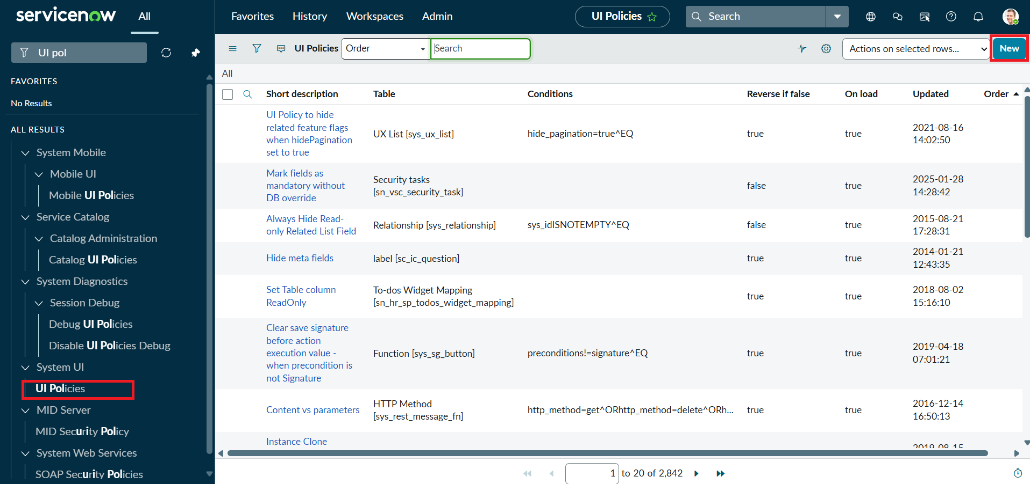
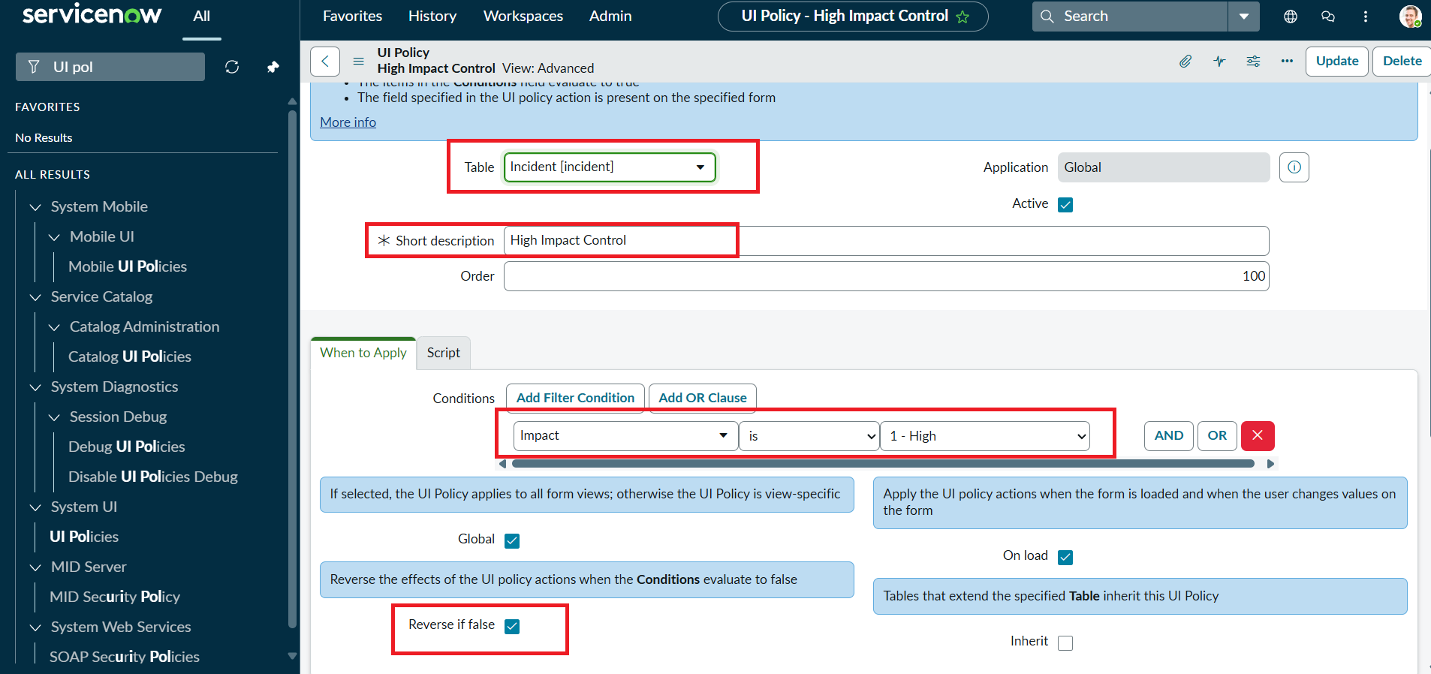
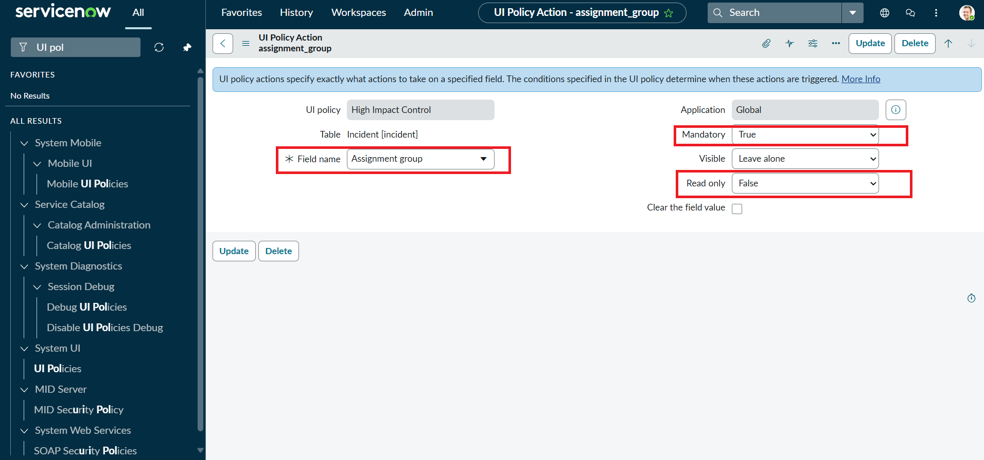
3.2 Design of UI Policy Action — Urgency
Linked to the High Impact Control UI Policy, this action controls the Urgency field:
Property | Configured Value
Field name | Urgency
Read-only | true
Visible | Unchanged (remains visible)
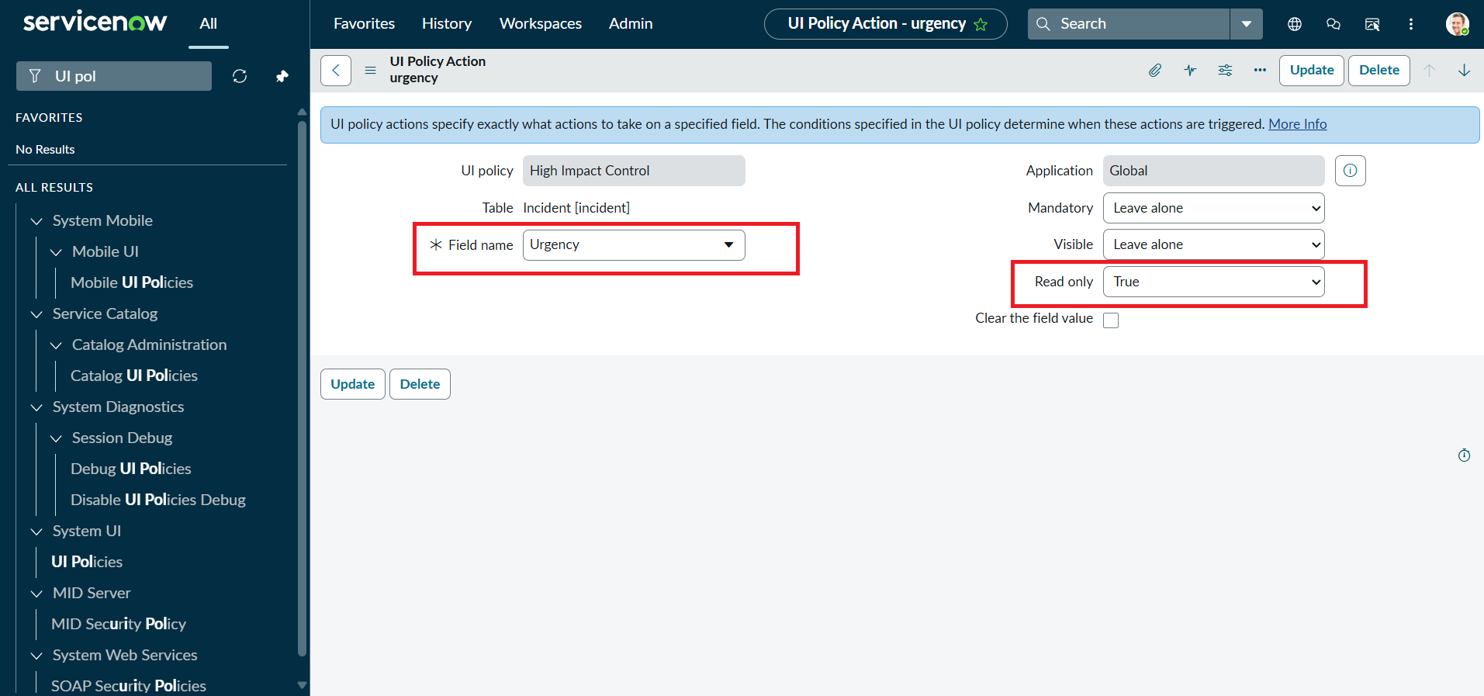
3.3 Design of Client Scripts
Script Name | Type | Purpose
Auto set urgency for high impact | onChange | Automatically sets Urgency to High when Impact changes to High.
Prevent save if Assigned To missing | onSubmit | Blocks save when Impact is High and Assigned To is empty.
Prevent state change via list edit | onCellEdit | Blocks direct editing of the State field from list view.
Phase 4: Project Planning Phase
The project was planned and broken down into the following sequential tasks, each with a clear deliverable:
Task | Task Name | Deliverable
Task 1 | Create UI Policy on Incident | High Impact Control UI Policy configured on the Incident table.
Task 2 | Create UI Policy Action — Urgency | UI Policy Action making Urgency read-only when triggered.
Task 3 | Create onChange Client Script | Script that auto-sets Urgency when Impact changes to High.
Task 4 | Create onSubmit Client Script (Save Validation) | Script that blocks save when Assigned To is missing for High impact.
Task 5 | Create onCellEdit Client Script | Script that blocks State field editing from list view.
Task 6 | Testing the Configuration | Verification of all UI Policy and Client Script behaviors end-to-end.
This plan ensured that configuration tasks (UI Policy and UI Policy Action) were completed before the dependent Client Scripts, and that all functionality was validated together during the testing phase.
Phase 5: Project Development Phase
Task 1: Create UI Policy on Incident
- Log in to the ServiceNow instance with administrative or configuration access.
- Navigate to System UI → UI Policies.
- Click New to create a new UI Policy record.
- Set Name: High Impact Control, Table: Incident, Active: true.
- Configure the condition: Field = Impact, Operator = is, Value = 1 - High.
- Add the UI Policy Action for Assignment group and check Mandatory.
- Set Reverse if false to true, so field changes revert automatically when the condition is not met.
- Review the configuration and click Submit to save the UI Policy.
Task 2: Create UI Policy Action — Urgency
- Open the High Impact Control UI Policy created in Task 1 and scroll to the UI Policy Actions related list.
- Click New to create a UI Policy Action.
- Set Field name: Urgency, Read-only: true, and leave Visible unchanged.
- Click Submit to save the action.
- Verify by setting Impact to High on an Incident and confirming that Urgency becomes read-only, then reverting Impact to confirm the field is editable again.
Task 3: Create onChange Client Script
- Navigate to System UI → Client Scripts and click New.
- Set Name: Auto set urgency for high impact, Table: Incident, Type: onChange, Field name: Impact, Active: true.
- Paste the script shown below into the script editor and click Submit.
function onChange(control, oldValue, newValue, isLoading) {
if (isLoading || newValue == '') {
return;
}
if (newValue == '1') {
g_form.setValue('urgency', '1');
g_form.addInfoMessage('Urgency set to High for High impact incident.');
}
}
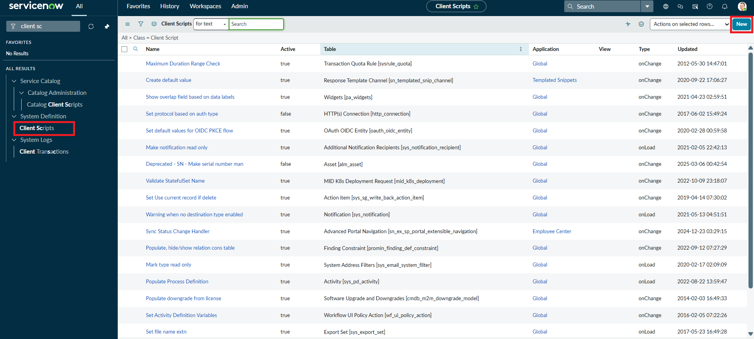
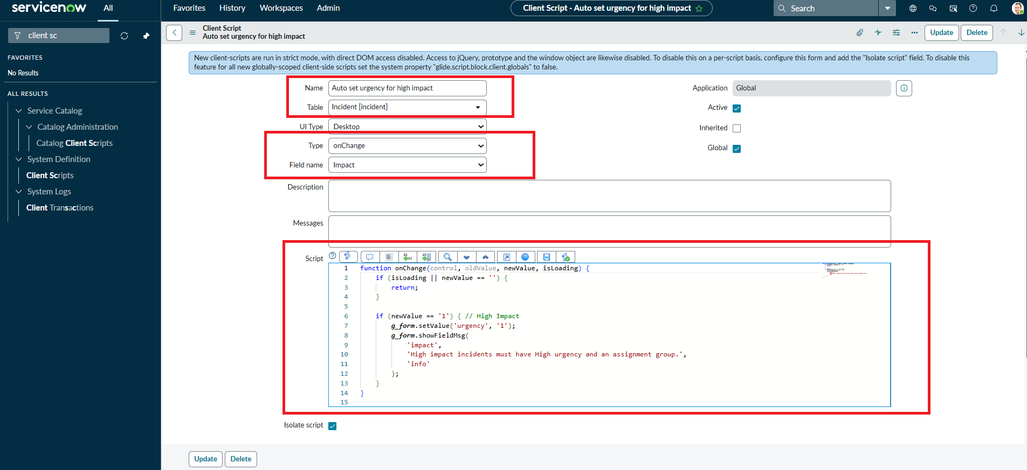
Task 4: Create onSubmit Client Script (Save Validation)
- Navigate to System UI → Client Scripts and click New.
- Set Name: Prevent save if Assigned To missing, Table: Incident, Type: onSubmit, Active: true.
- Paste the script shown below into the script editor and click Submit.
function onSubmit() {
if (g_form.getValue('impact') == '1' &&
g_form.getValue('assigned_to') == '') {
g_form.showErrorBox(
'assigned_to',
'Assigned To is mandatory for High impact incidents.'
);
return false;
}
return true;
}
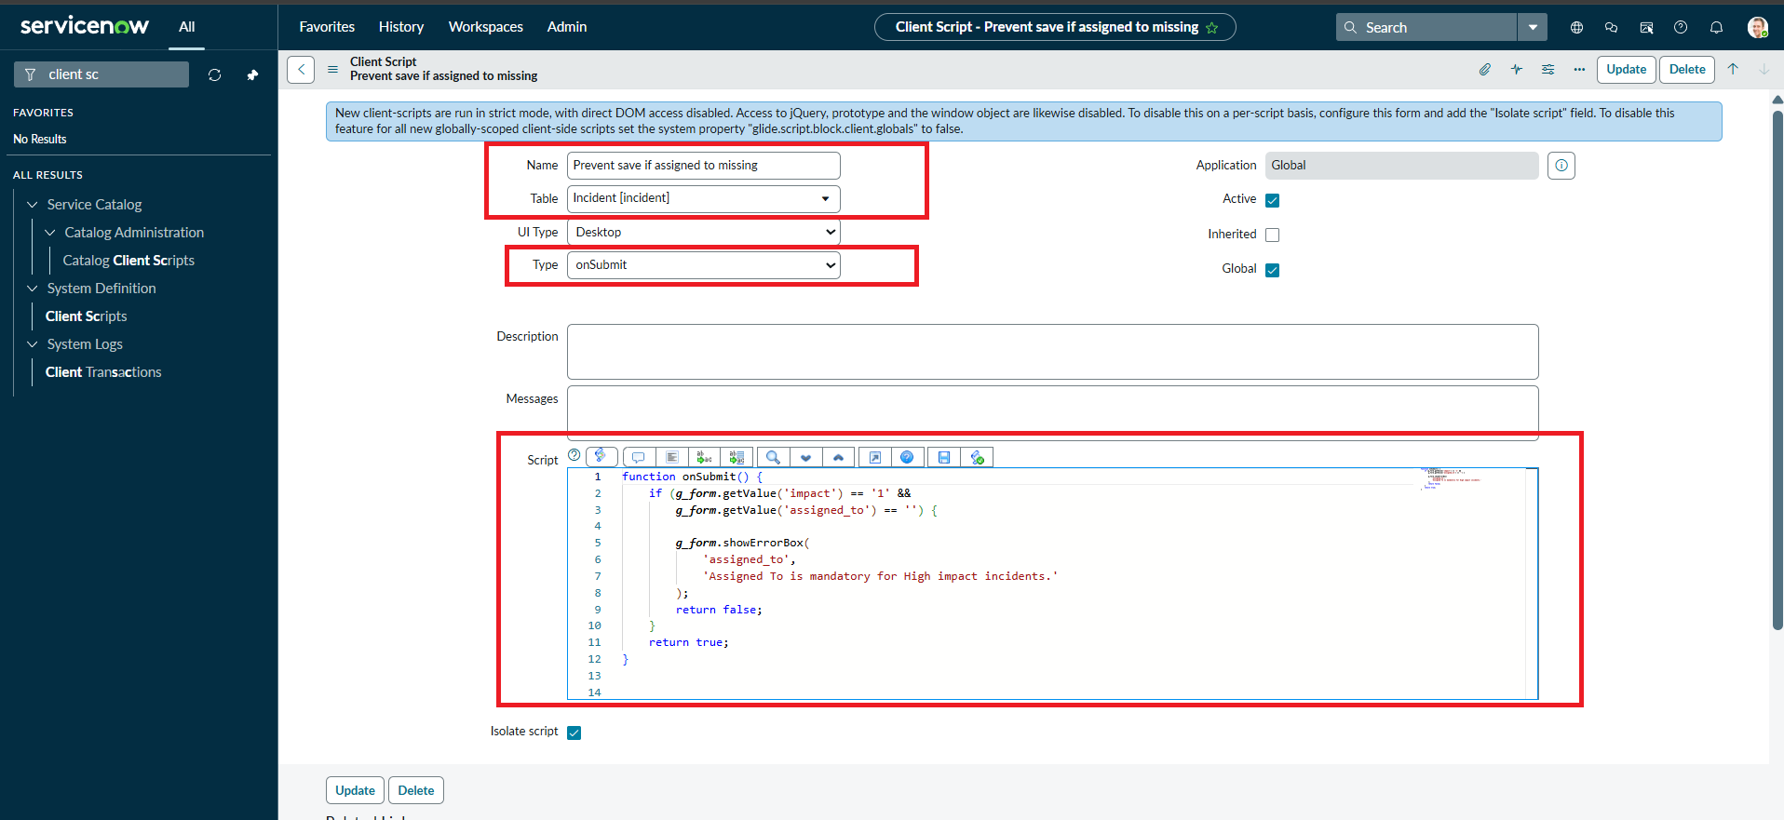
Task 5: Create onCellEdit Client Script
- Navigate to System UI → Client Scripts and click New.
- Set Name: Prevent state change via list edit, Table: Incident, Type: onCellEdit, Field name: State, Active: true.
- Paste the script shown below into the script editor and click Submit.
function onCellEdit(sysIDs, table, oldValues, newValue, callback) {
alert('State cannot be updated using list editing. Please open the Incident.');
callback(false);
}
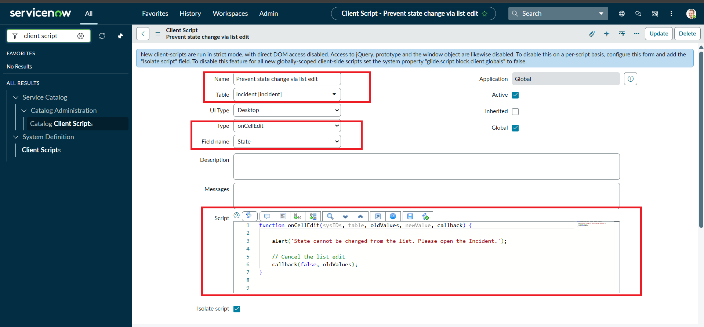
Phase 6: Project Testing Phase
Activity 1: Test Mandatory Enforcement
A new Incident was created and Impact was set to High while leaving Assigned To empty. On Submit, the record was not saved — an error message appeared indicating that Assigned To cannot be empty, and all other UI Policy actions (read-only fields, automated Urgency update) behaved as expected.
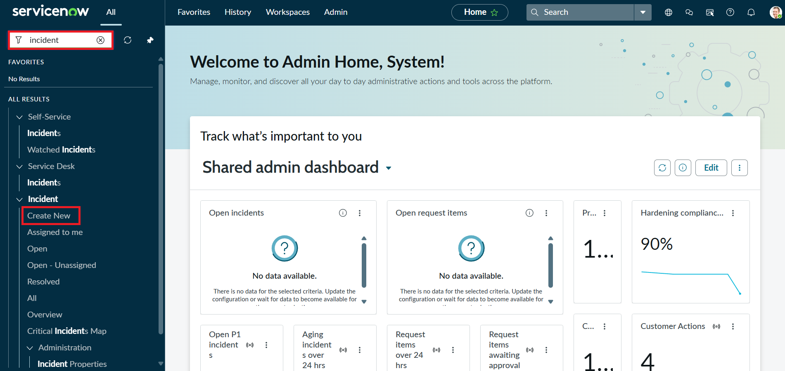
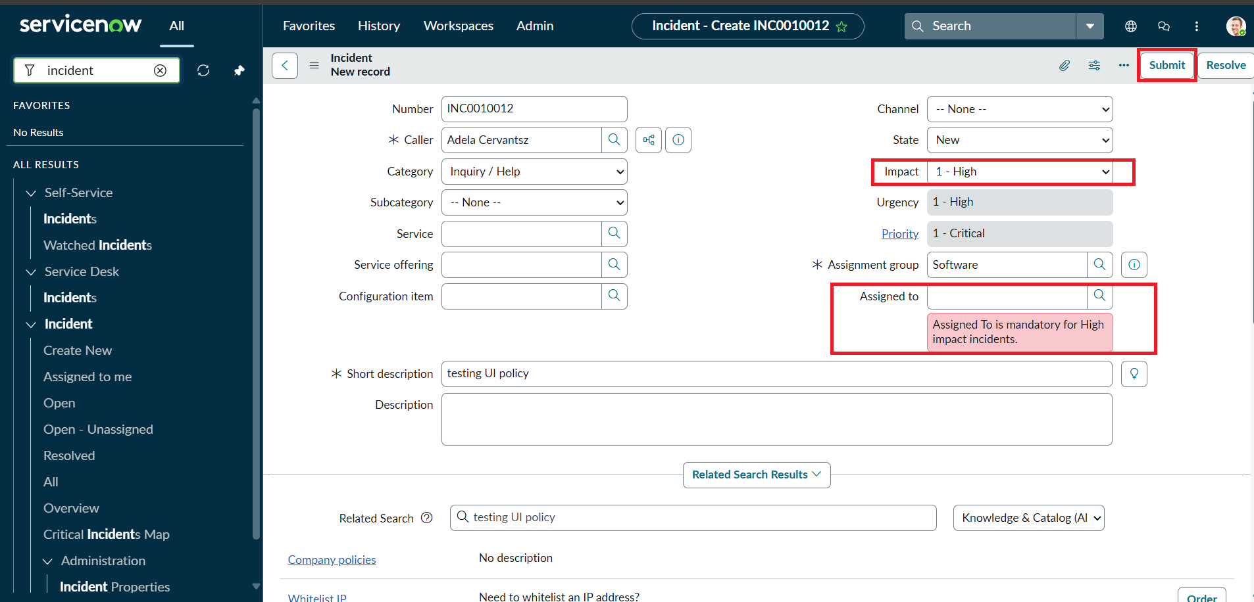
Activity 2: Test Successful Save
The Assigned To field was filled and the Incident was submitted again. The record saved successfully without errors, and the Urgency auto-setting, read-only field behavior, and State restrictions all functioned as expected.
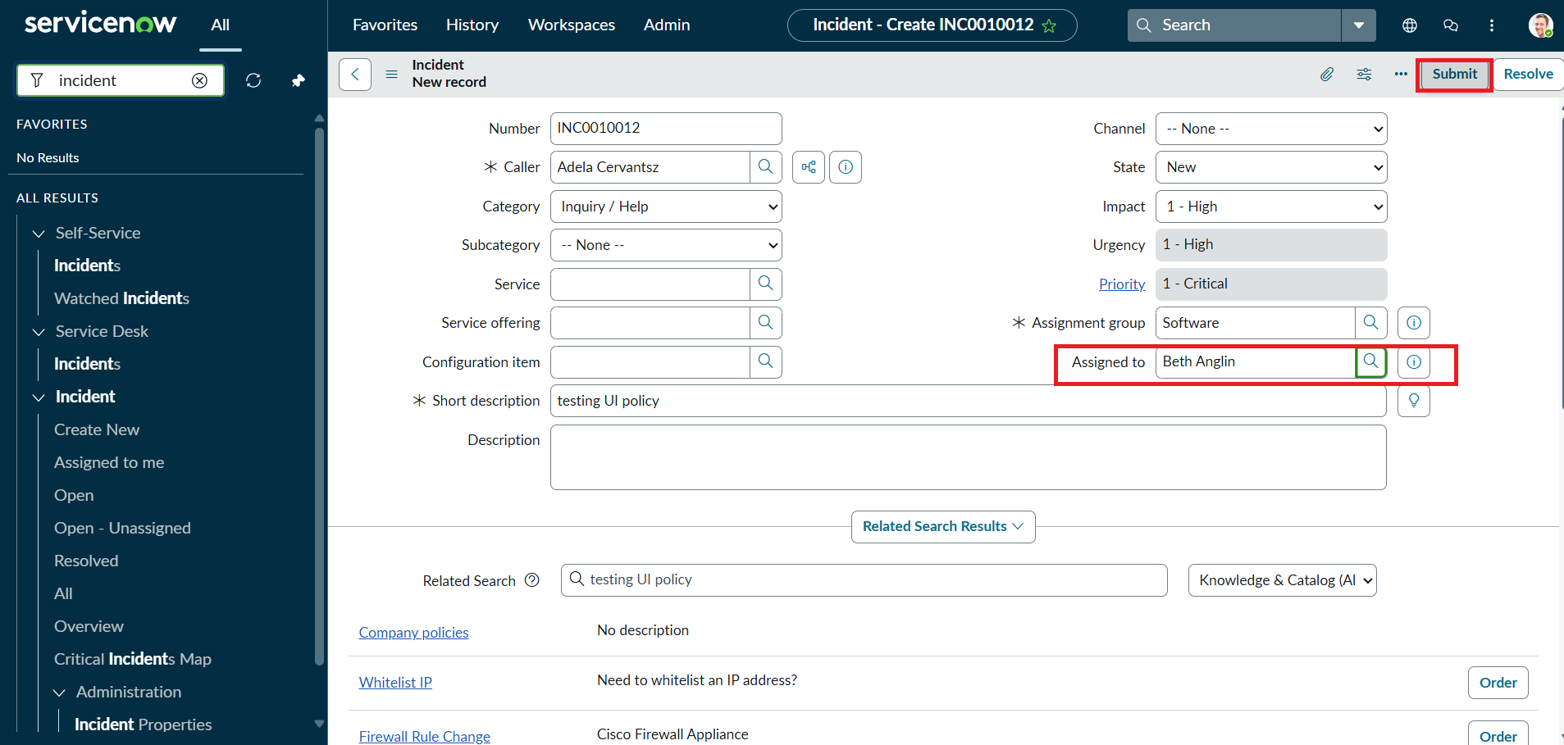
Activity 3: Reverse Condition Test
An existing High Impact Incident was updated by changing Impact from High to Medium. Assigned To was no longer mandatory and Urgency became editable again, confirming that the Reverse if false setting worked correctly. The record saved successfully.
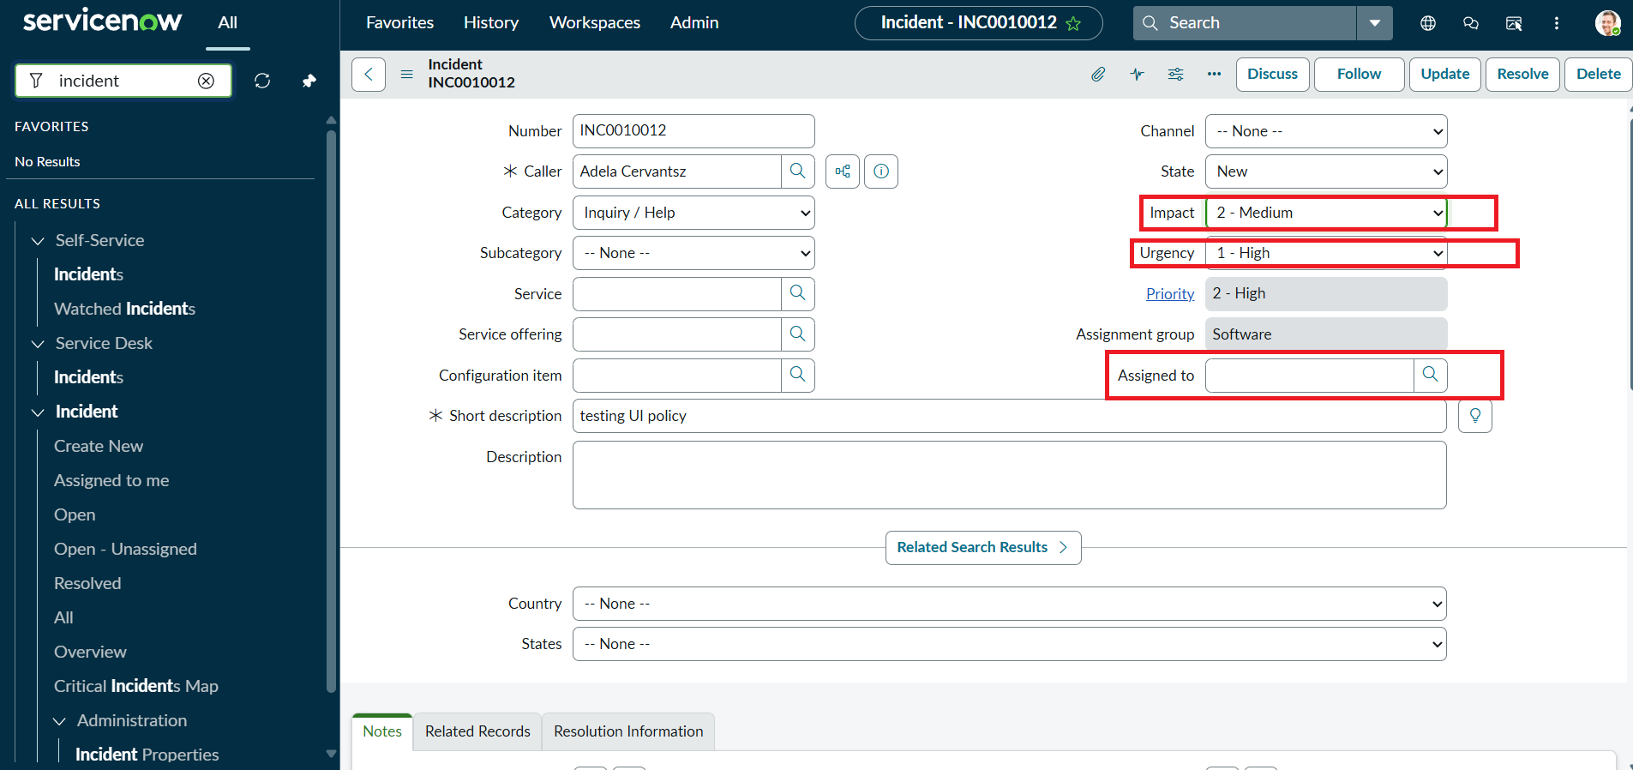
Activity 4: Test List Edit Blocking
From the Incident list view, an attempt was made to double-click and edit the State field directly. An alert message appeared indicating that direct changes to State are not allowed, and the State value remained unchanged, confirming the onCellEdit script worked correctly.
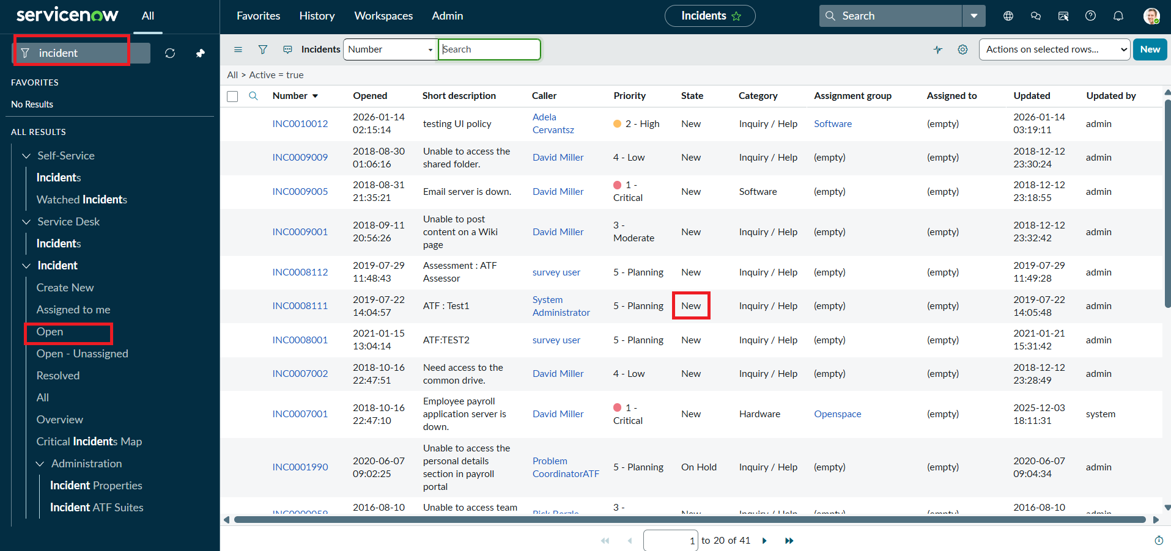
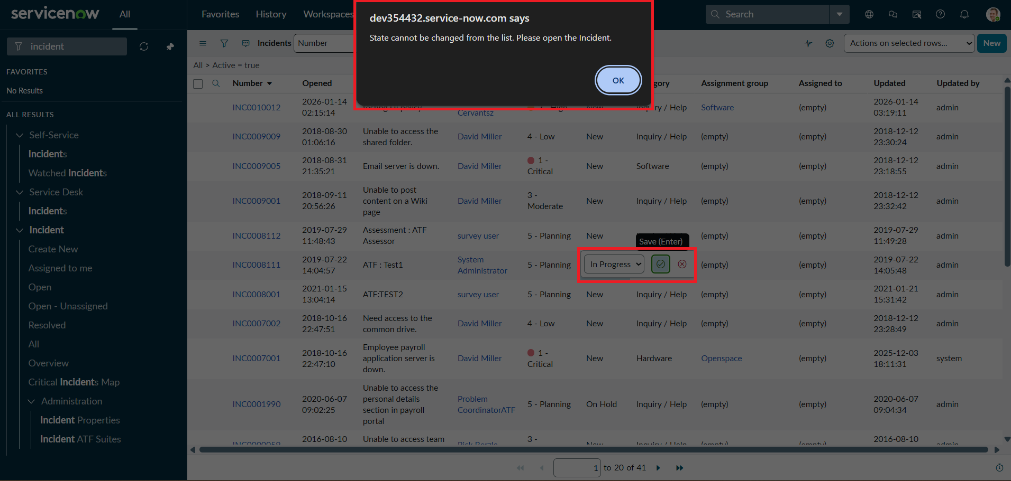
Activity 5: Test Form-Based Update
The same Incident was opened on the form and the State field was updated normally, then saved using Update. The change was saved successfully, confirming that form-based updates remain unaffected while list-based edits are blocked, and that Assigned To and Urgency continued to follow the configured rules.
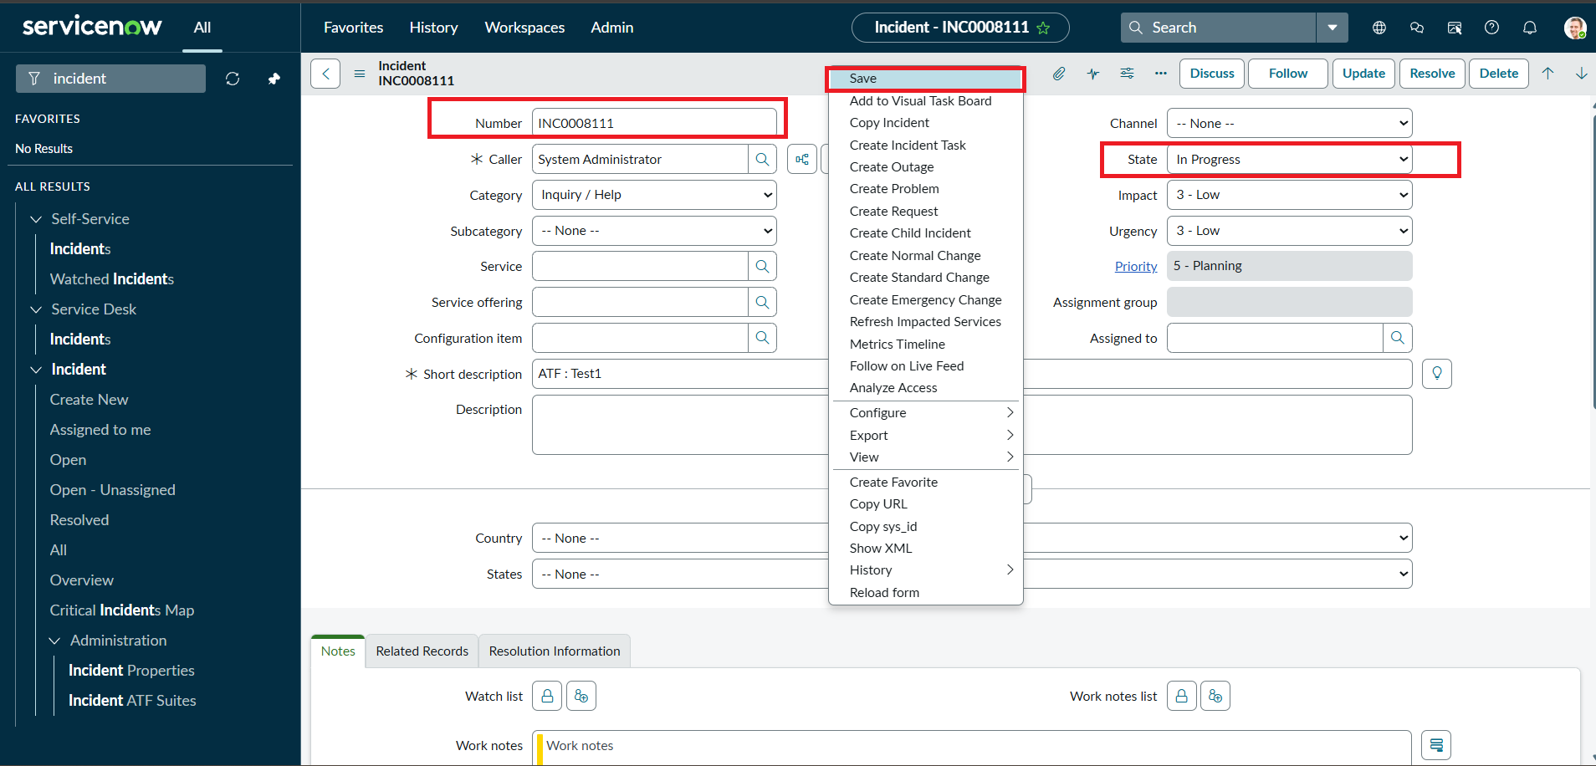
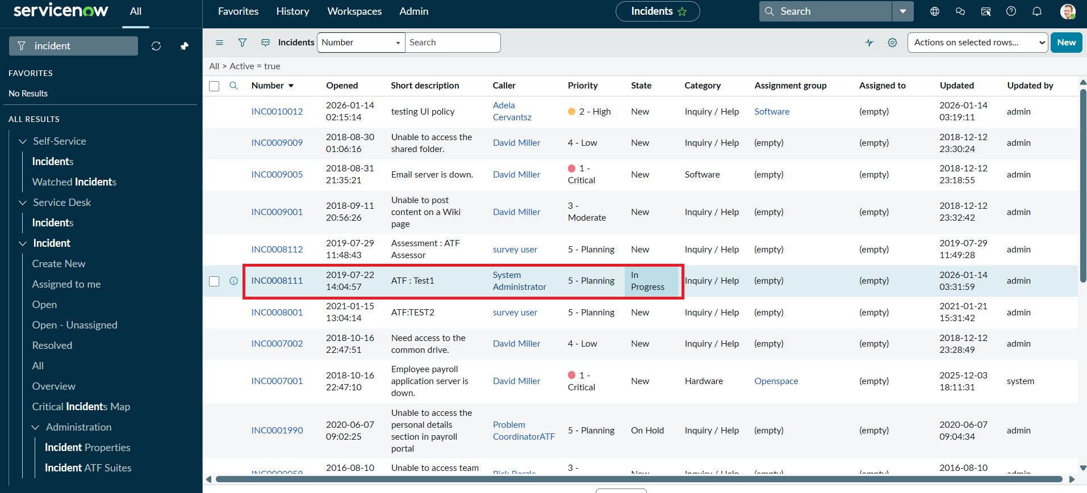
Phase 7: Project Documentation Phase
All configuration items created during this project were documented for future reference and maintainability. This document itself forms the primary project documentation and includes the problem statement, objective, requirements, design, step-by-step development, and test evidence.
Documentation Checklist
- UI Policy 'High Impact Control' — name, table, condition, and action configuration recorded (Phase 3).
- UI Policy Action for Urgency — field behavior and Reverse if false setting recorded (Phase 3).
- Client Script 'Auto set urgency for high impact' (onChange) — purpose and script logic recorded (Phase 5).
- Client Script 'Prevent save if Assigned To missing' (onSubmit) — purpose and script logic recorded (Phase 5).
- Client Script 'Prevent state change via list edit' (onCellEdit) — purpose and script logic recorded (Phase 5).
- Test cases and screenshots for all five verification activities recorded (Phase 6).
Naming conventions were kept descriptive (e.g., 'Prevent save if Assigned To missing') so that each configuration item is self-explanatory to future administrators reviewing the Incident form configuration.
Phase 8: Project Demonstration Phase
The completed solution was demonstrated end-to-end on a live Incident record: setting Impact to High triggered the UI Policy and Client Scripts together — Assignment Group became mandatory, Urgency was automatically set to High and made read-only, and attempting to submit without an Assigned To value was blocked with a clear validation message. Once Assigned To was filled, the record saved successfully. Reverting Impact to Medium demonstrated the Reverse if false behavior, and an attempt to edit the State field from the list view was blocked as designed, while the same change succeeded from the Incident form.
Conclusion
The Implement Client Script & UI Policy (Incident) project effectively demonstrates how UI Policies and Client Scripts can work together to enforce dynamic field behavior, automate updates, and prevent incorrect data submission on Incident forms. By using onChange, onSubmit, and onCellEdit scripts alongside UI Policy actions, the project ensures fields like Assigned To and Urgency respond appropriately to changes in Impact, maintaining clean and consistent data. This solution enforces mandatory fields, controls user interactions, and remains lightweight, efficient, and easy to implement — showcasing practical best practices for improving form usability and data integrity in ServiceNow.

